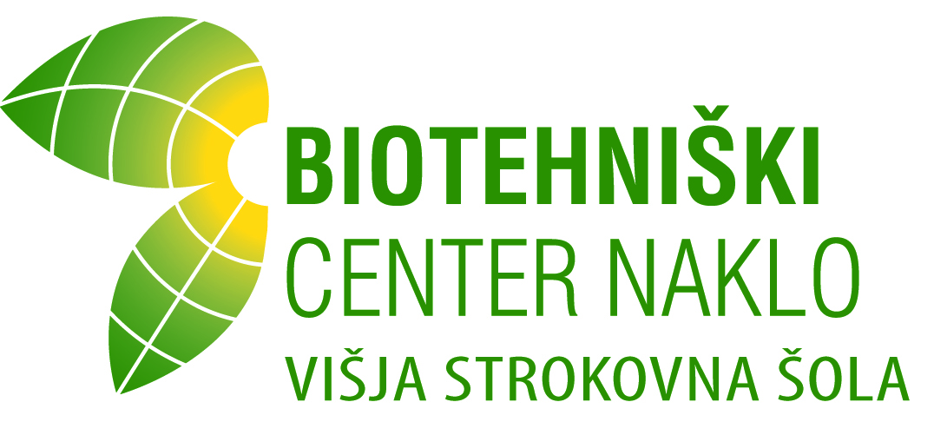

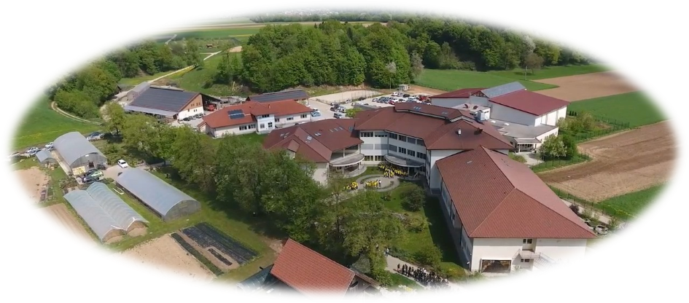

Countryside and Landscape Management Study Programme

1 Information on higher professional education

1.1 Name of qualification and the title conferred (in original language):
Name of the document: Diploma of Higher Professional Education
Title of professional education: Agriculture and Landscape Engineer (Inženir kmetijstva in krajine)
Abbreviation of the title of professional education (in the original language): inž. kmet. in kraj.

1.2 Field of study, Study programme, module:
Undergraduate Short-Cycle Higher Vocational Study Programme – COUNTRYSIDE AND LANDSCAPE MANAGEMENT.

The programme is divided:
1. All compulsory modules and subjects comprising 52 credit points (ECTS):
- Business and Economics (15 ECTS),
- Communication and Informatics (12 ECTS),
- Entrepreneurship with organisation (18 ECTS)
- Sustainable development with selected chapters from biology (4 ECTS)
- Countryside development with legislation (5 ECTS),
- Plant growing and animal breeding (7 ECTS).
2. Optional subjects comprising 37 credits (ECTS):
- Management in agriculture and horticulture (8 ECTS)
- Management in fruit growing and viticulture (7 ECTS)
- Plant protection with phytopharmacy (8 ECTS)
- Growth and usage of beneficial organisms (7 ECTS)
- Cattle breeding management (8 ECTS)
- Medical protection of domestic animals (7 ECTS)
- Tourism and recreation in the countryside (8 ECTS)
- Horse training and riding lessons (7 ECTS)
- Management of recreational and sports areas (22 ECTS)
- Ecological food production (7 ECTS)
- Logistics and mechanisation in agriculture (7 ECTS)
- Winemaking (15 ECTS)
- Protection of natural values and biodiversity (7 ECTS)
- Therapeutic and social activity in the countryside (7 ECTS)
3. Free elective module / subject (5 ECTS)
4. Diploma exam (5 ECTS)


Short-Cycle Higher Vocational Study Programme Countryside and Landscape Management was verified by the Professional Council of the RS for vocational and professional education and training (95th session, 18th December 2006). Considering a suggestion of the Professional Council of the RS for vocational and professional education and training the minister for education verified a supplemented study programme. A regulation of its verification was issued in the Official Gazette of RS, no. 43/2007.

1.3 Name of the degree-granting higher education institution:
Biotechnical Centre Naklo – Vocational College
Strahinj 99
4202 Naklo

1.4 Number and date of the decision to enter the provider in the Register of providers of Officially recognised education programmes, namely for the respective study programme:
Biotechnical Centre Naklo, Higher Vocational College, entered the Register of providers of Officially recognised education programme under the serial number 49 with the Decisions of the Ministry of Education, Science and Sport: No. 6033-658/2008 on 5th January 2009; No. 6033-457/2016/2 on 3rd November 2016.

1.5 Legal status of awarding institution: public

1..6 Language(s) of instruction/examination: Slovene

2 INFORMATION ON THE LEVEL OF THE QUALIFICATION

2.1 Level of qualification: higher vocational education, SOK/NQF 6, EOK/EQF 5, EOVK/EHEQF Short cycle

2.2 Official length of study programme: two years, 120 credit points (ECTS)

2.3 Access requirements:
Post-secondary study program is open to anyone who:
- has passed Matura exam, Vocational Matura exam (or Final exam respectively Diploma before the introduction of Vocational Matura exam) at grammar school, any program of secondary vocational education (also any program of vocational technical education) or has completed Vocational Courses;
- has passed the Master Craftsman or Foreman exams or if the applicant has three years of work experience and has passed a test of knowledge of Slovenian language and literature, mathematics or foreign language to the extent provided for Vocational Matura.
Criteria for candidates’ selection in the circumstances of limited enrolment:
- The candidates who have finished Grammar school or other programme of secondary professional education (including five-year programmes, continuation programmes of secondary education or vocational-technical education) or a vocational course will be allowed to put forward the addition: the grades of general success in leaving examination, leaving vocational examination or final examination multiplied by factor 2 (expressed in points and transmitted into a grade scale 2-5) and grades of general success in the 3rd and the 4th year or in the last two years of the secondary education.
- Candidates who have passed exams for Master craftsman, Supervisor and Foreman will be able to put forward the addition: the grades of general success in skilled worker, supervisor or foreman’s examination multiplied by factor 2 (expressed in points and transmitted into a grade scale 2-5) and grades of tests in Slovene language and literature, mathematics or foreign language.

3 INFORMATION ON THE STUDIES AND THE RESULTS GAINED

3.1 Mode of study: full-time / part-time

3.2 Study programme requirements and student obligations:
Number of hours of lectures and tutorials: 1200 hours
Number of hours of practical training: 800 hours
Credits (ECTS): 120
Attendance at lectures, tutorials and laboratory work is determined by the curriculum. Within the practical education that the student performed at the company under contract, the student manufactures a product (project work) or performs a service with the defense.
After successful completion of all obligations which are determined by the educational program, student passes Diploma examination. Diploma exam consists of a thesis and a defense. Topic of the thesis is determined by the mentor at the organization where the student performed practical training and a lecturer at higher professional school. Instead of a thesis a student can implement a project or product or service with the defense.
3.3 Study programme details:
Code | Module / subject / or other components of the programme | Compulsory /optional | Year of study | Number of hours |  |  | Total number of teaching hours | Credit points (CP)
 |  |  |  | LC | SW | LW | Total number of teaching hours | Credit points (CP)
M1 | BUSINESS AND ECONOMICS | compulsory | 1 |  |  |  |  | 12
S1 | Business communication and management |  | 1 | 42 | 6 | 24 | 72 | 6
S2 | Economics and management of companies |  | 1 | 42 | 6 | 24 | 72 | 6
M2 | COMMUNICATION AND INFORMATICS | compulsory | 1 |  |  |  |  | 9
S3 | Professional terminology in a foreign language |  | 1 | 30 | 0 | 30 | 60 | 5
S4 | Professional information science with statistical methods of assesment |  | 1 | 18 | 6 | 24 | 48 | 4
M3 | ENTERPRENEURSHIP WITH ORGANISATION | compulsory | 2 |  |  |  |  | 15
S5 | Entrepreneurship and marketing |  | 2 | 48 | 6 | 48 | 102 | 7
S6 | Organization and business management |  | 2 | 60 | 6 | 48 | 114 | 8
M4 | PLANT PRODUCTION MANAGEMENT | optional | 1 or2 |  |  |  |  | 15
S7 | Management in agriculture and horticulture |  | 1 or 2 | 60 | 6 | 48 | 114 | 8
S8 | Management in fruit growing and viticulture |  | 1 or 2 | 54 | 6 | 42 | 102 | 7
M5 | PLANT PROTECTION | optional | 1 or 2 |  |  |  |  | 15
S9 | Plant protection with phytopharmacy |  | 1 or 2 | 60 | 6 | 48 | 114 | 8
S10 | Growth and usage of beneficial organisms |  | 1 or 2 | 54 | 6 | 42 | 102 | 7
M6 | ANIMAL BREEDING MANAGEMENT | optional | 1 or 2 |  |  |  |  | 15
S11 | Cattle breeding management |  | 1 or 2 | 60 | 6 | 48 | 114 | 8
S12 | Medical protection of domestic animals |  | 1 or 2 | 54 | 6 | 42 | 102 | 7
M7 | TOURISM AND SPORT IN THE COUNTRYSIDE | optional | 1 or 2 |  |  |  |  | 15
S13 | Tourism and recreation in the countryside | optional | 1 or 2 | 60 | 6 | 48 | 114 | 8
S14 | Horse training and riding lessons | optional | 1 or 2 | 54 | 6 | 42 | 102 | 7
S15 | Sustainable development with selected chapters from biology | compulsory | 1 | 12 | 0 | 36 | 48 | 4
S16 | Countryside development with legislation | compulsory | 2 | 36 | 6 | 30 | 72 | 5
S17 | Plant growing and animal breeding | compulsory | 1 | 42 | 0 | 42 | 84 | 7
S18 | Management of recreational and sports areas | optional | 2 | 176 | 12 | 124 | 312 | 22
S19 | Ecological food production | optional | 1 or 2 | 54 | 0 | 42 | 96 | 7
S20 | Logistics and mechanisation in agriculture | optional | 1 or 2 | 54 | 0 | 42 | 96 | 7
S21 | Therapeutic and social activities in the countryside | optional | 1 or 2 | 54 | 0 | 42 | 96 | 7
S22 | Protection of natural values and biodiversity | optional | 1 or 2 | 54 | 0 | 42 | 96 | 7
O1 | Practical training 1 | compulsory | 1 |  |  |  | 400 | 13
O2 | Practical training 2 | compulsory | 2 |  |  |  | 400 | 13
S24 | Free elective module / subject | optional | 1 or 2 |  |  |  | 72 | 5
O3 | Diploma exam | compulsory | 2 |  |  |  |  | 5
 | TOTAL CREDIT POINTS |  |  |  |  |  |  | 120
Abbreviations: M – module, S – subject, O – other component, LC– lectures, SW –seminar work, LW – laboratory work, CP – credit points according to European Credit Transfer System (ECTS).

3.4 Individual grades/credits obtained: /

3.5 Student average grade: «Average»

3.6 Grading scheme:
10 | – | Excellent (exceptional achievement with negligible mistakes)
9 | – | Very Good (above-average but with some mistakes)
8 | – | Very Good (commendable achievement)
7 | – | Good (good knowledge yet with major mistakes)
6 | – | Sufficient (complies with minimum criteria)
1–5 | – | Insufficient (does not comply with minimum criteria)

4 INFORMATION ON THE FUNCTION OF THE QUALIFICATION

4.1 Access to further study:
Graduates of the Short-Cycle Higher Vocational Study Programme Nature protection can enrol in the second year of the First Cycle Professional Study Programme. Conditions for this kind of transition may be defined by the First Cycle Professional Study Programme, which can opt for bridging exams and choose the approved second and third year subjects.

4.2 Professional status:
The basic goals of the programme are:
- to educate engineers with sufficient professional theoretical and useful practical knowledge for producing food and managing landscape,
- to gain generic and vocational specific competence of professional field of agriculture and landscape,
- to gain and hollow theoretical and practical knowledge about agriculture, countryside and to form whole survey on countryside and landscape,
- to form responsible relationship toward making quality at work,
- to form self-confidence and determination to make business decisions and for solving concrete professional problems.

So, he or she who finishes agriculture and landscape programme knows:
- how to use agriculture technologies nice to environment and how to use alternative sources of energy;
- to effectively organize, carry out and follow agriculture production, processing and completion of agriculture products;
- to form trademark and modern methods of trading in agriculture and other activities in the countryside;
- to manage the sell of agriculture products and service and products in additional activities.

Employment opportunities: head of the farm, farm with supplementary activities, tourist farms, agricultural enterprises, agricultural trade or agricultural cooperative, a foreman, an organizer of agricultural production, consulting activities in the field of agriculture, co-worker in the preparation and implementation of rural development projects, co-worker in collective centres with vegetables and fruits or in wine cellar, co-worker in the inspection organization for organic and integrated production, self-employment, etc.


5 Additional information

5.1 Additional information:
Information on the higher education study programme is available on the website of Center za poklicno in strokovno izobraževanje http://www.cpi.si/visjesolski-studijski-programi.aspx.
Information on the ERASMUS+ programme: http://www.erasmusplus.si/

5.2 Sources of further information:

Biotechnical Centre Naklo –Higher Vocational College |  | Ministry of Education, Science and Sport
99 Strahinj |  | 16 Masarykova cesta
Naklo 4202 |  | Ljubljana 1000
Phone: +386 (0) 4 277 21 00 |  | Phone: +386 (0)1 400 5200
E-mail: info@bc-naklo.si |  | Fax: +386 (0)1 400 5321
Web page: http://www.bc-naklo.si |  | E-mail: gp.mizs@gov.si
 |  | Web page: http://www.mizs.gov.si
  ENIC-NARIC center
  Kotnikova 38
  1000 Ljubljana
  tel.: (01) 478 47 45
  faks: (01) 478 47 19
  E-naslov: enicnaric-slovenia.mvzt@gov.si
  Špela Langus (Erasmus+ coordinator), spela.langus@bc-naklo.si, +38651455946
  Spletni naslov: www.mizs.gov.si
  Slovensko ogrodje kvalifikacij (SOK):
  Spletni naslov: http://www.nok.si/

Špela Langus (Erasmus+ coordinator), spela.langus@bc-naklo.si, +38651455946

6 INFORMATION ON THE SHORT-CYCLE HIGHER VOCATIONAL EDUCATION SYSTEM IN THE REPUBLIC OF SLOVENIA
The short-cycle higher vocational education in the Republic of Slovenia is regulated by the Short-Cycle Higher Vocational Education Act (Uradni list RS, št. 86/2004 in 100/2013). The short-cycle higher vocational education is part of terciary education. Upon the completion of a short-cycle higher vocational education programme, it is possible to enter a specialisation study programme or a supplementary study programme at the same level.

Upon a successful completion of a short-cycle higher education programme, a diploma is awarded that indicates a professional title as specified by the Professional and Academic Titles Act (Uradni list RS, št. 61/2006).

Access to short-cycle higher vocational education studies is open to holders of a matura certificate or a vocational matura certificate (final examination obtained prior to 1 June 1995) and to those who have passed a master craftsman, foreman or shop manager exam, have three years of work experience and have passed a test in the Slovenian language and literature and mathematics or a foreign language in the scope prescribed for a vocational matura examination. Students complete their studies with a diploma thesis. Upon graduation from a higher vocational college, graduates may find employment or continue in higher professional study programmes on the basis of the recognition process.

Under certain conditions, transfers between a short-cycle higher vocational education programme and a higher education programme are possible in both directions. In a short-cycle higher vocational education programme, a student obtains 120 credit points (CP) under the European Credit Transfer and Accumulation System (ECTS). The diploma awarded to a student upon a successful completion of the degree will indicate the professional title obtained and the profession.

Levels of SQF, EQF and EHEQF

Slovenian Qualifications Framework Act (Uradni list RS, No. 104/15) in its Article 11 classified levels of Slovenian Qualifications Framework (from now on: SQF) into European Qualifications Framework (from now on: EQF) and in its Article 12 into European Higher Education Qualifications Framework (from now on: EHEQF).

Qualifications in the SQF, EQF and EHEQF are classified as evident in the following table:

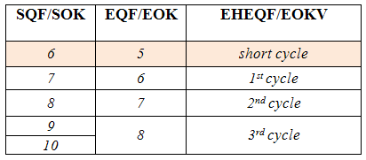
The quality of higher vocational colleges and short-cycle higher vocational study programmes is ensured through accreditation and internal and external evaluation procedures. The accreditation and prolongement of accreditation of short-cycle higher vocational study programmes and higher vocational colleges is the responsibility of Ministry of Education, Science and Sport and Commission
of Accreditation of higher vocational education study programmes and of higher vocational colleges, appointed by the Council of the Republic of Slovenia of Vocational and Professional Education. The external evaluation of higher vocational colleges and short-cycle higher vocational study programmes is the responsibility of the Slovenian Quality Assurance Agency for Higher Education. Higher vocational colleges are responsible for internal evaluation procedures.

STRUCTURE OF THE EDUCATION SYSTEM IN THE REPUBLIC OF SLOVENIA

