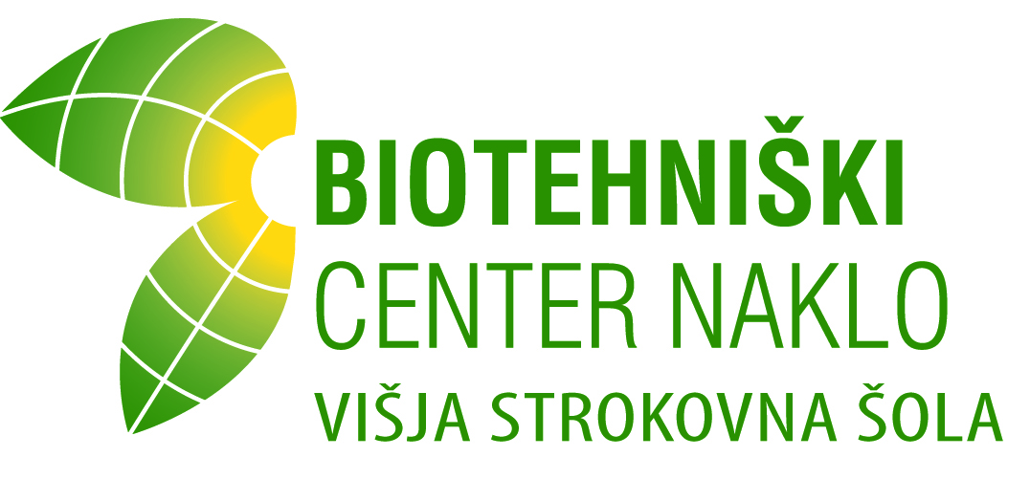

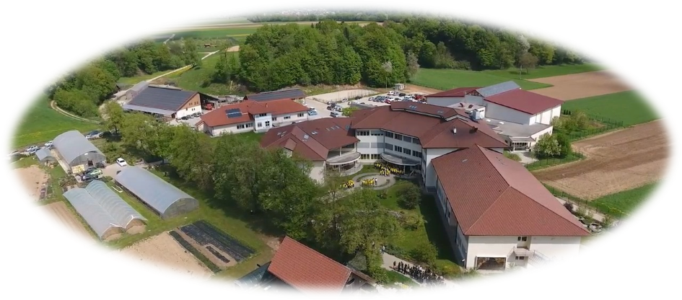

Food Technology and Nutrition Study Programme

Information identifying the qualification

1.1 Name of qualification and title conferred (in original language):
Designation of the granted document: Diploma o višji strokovni izobrazbi
Professional title: inženir/inženirka živilstva in prehrane
Abbreviation: inž. živil. in preh.

Classification by KLASIUS (SRV): 16101 – Higher vocational education
Classification by KLASIUS (P): 5410 – Food processing

1.2 Field of study, study programme, module:
Study programme: Food Technology and Nutrition

On the proposal of the Council of Experts of the Republic of Slovenia for Vocational and Technical Education (95th meeting, 18 December 2006), the undergraduate study programme to acquire higher vocational education in Food Technology and Nutrition was adopted by the Minister of Education and Sport, and the Rules regarding its adoption were published in the Official Gazette RS, No. 43/2007.

Study programme Food Technology and Nutrition is divided into:

- Compulsory Modules (54 ECTS): M1-Management and Economics; M2-Communication and Informatics; Sustainable Development with Selected Chapters from Biology; Food Microbiology and Biotechnology; Technological Processes with Safety at Work, Packaging and Logistics; Nutrition and Health; Food Chemistry with Food Analysis; Legislation, Quality Assurance and Control.
- Optional Modules (20 ECTS): M3-Food Technologies; M4-Nutrition, Dietetics and Gastronomy;
- Elective Subjects (15 ECTS).

1.3 Name of institution (in original language):
BIOTEHNIŠKI CENTER NAKLO
VIŠJA STROKOVNA ŠOLA
Strahinj 99, 4202 Naklo

1.4 Number and date of the decision to enter the provider in the Register of providers of officially recognised education programmes, namely for the respective study programme:

By means of Decision of the Ministry of Education and Sport No. 6033-126/2020/6, dated 17 February 2021, the higher vocational school was entered in the register of institutions authorised to carry out a higher education programme in Food Technology and Nutrition.

1.5 Legal status of awarding institution: Public

1.6 Language(s) of instruction/examination: Slovenian

2 Information on the level of the qualification
2.1 Level of qualification: higher vocational education, SQF/SOK 6, EQF/EOK 5, EHEQF/ EOVK Short cycle

2.2 Official length of study programme: 2 years and 120 credit points (ECTS)

2.3 Access requirements:
The higher vocational education study programme may be undertaken by anyone who has:
- passed a matura examination, vocational matura examination (or final examination and/or a diploma prior to introduction of the vocational matura examination) according to the programme of general upper secondary school, any programme to acquire secondary professional education (including programmes to acquire vocational technical education) and/or passed a vocational course, and
- passed the master craftsman or foreman and/or manager examination or has three years of work experience and passed a test in the Slovenian language with literature and mathematics or in a foreign language within the scope provided by the vocational matura examination.

2.4 Further information:
Further information on the higher education study programme is available on the website of Višja strokovna šola http://www.bc-naklo.si/visja-sola/
and Center za poklicno in strokovno izobraževanje http://www.cpi.si/visjesolski-studijski-programi.aspx and the website SQF http://www.nok.si/en/.

3 Information on the contents and results gained

3.1 Mode of study: Full time / Part-time

3.2 Study programme requirements and student obligations:
Number of lectures and exercises: 1200 hours
Practical training: 800 hours
Number of credit points under ECTS: 120 credit points

Attendance at lectures, seminar exercises and laboratory exercises is determined by the implementing curriculum.
Within the scope of practical training of students in companies based on their contracts, students shall prepare project work and present their diploma paper. Upon completion of all obligations set forth by the study programme, students shall also have to pass a diploma examination.

The graduate of the higher study programme in Food Technology and Nutrition has acquired the following:

General competencies:
- participating in professional development and introducing new ideas into the profession;
- planning, organising and controlling technological and production processes;
- organising and managing work processes in cooperation with the experts in the field of environmental maintenance and protection;
- using the acquired communication skills in the workplace and other social settings;
- using selected statistical methods of data processing;
- applying the knowledge of economics, company management and marketing in the fields of food technology and nutrition;

Vocational-specific competencies:
- demonstrating knowledge in the field of food quality;
- managing technological processes and preparing safe and healthy food;
- selecting materials used in production;
- ensuring quality of production processes and food as well as food preparation;
- taking part in improving eating habits for different ages;
- applying the theoretical knowledge of food technology, nutrition and food safety when solving practical problems in the workplace;
- making decisions, selecting and using suitable methods to ensure appropriate food content and food quality;
- making decisions, selecting and using materials in food manufacturing and food preparation processes.

3.3 Study programme details:
No. | Module/Subject/Other component | Compulsory/Optional | Year | Number of hours |  |  |  | Total student load | Credit points  (ECTS)
 |  |  |  | LE | SE | LW | Total | Total student load | Credit points  (ECTS)
M1 | Management and Economics | Compulsory |  |  |  |  |  |  | 12
P1 | Business Communication and Management | Compulsory | 1 | 42 | 6 | 24 | 72 | 180 | 6
P2 | Economics and Management of Companies | Compulsory | 1 | 42 | 6 | 24 | 72 | 180 | 6
M2 | Communication and Informatics | Compulsory |  |  |  |  |  |  | 9
P3 | Professional Terminology in a Foreign Language | Compulsory | 1 | 30 | - | 30 | 60 | 150 | 5
P4 | Professional Information Science with Statistical Methods of Assessment | Compulsory | 1 | 18 | 6 | 24 | 48 | 120 | 4
P5 | Sustainable Development with Selected Chapters from Biology | Compulsory | 1 | 12 | - | 36 | 48 | 120 | 4
P6 | Food Microbiology and Biotechnology | Compulsory | 1 | 36 | 6 | 30 | 72 | 150 | 5
P7 | Technological Processes with Safety at Work, Packaging and Logistics | Compulsory | 1 | 48 | 12 | 36 | 96 | 210 | 7
P8 | Nutrition and Health | Compulsory | 1 | 30 | 6 | 12 | 48 | 120 | 4
P9 | Food Chemistry with Food Analysis | Compulsory | 1 | 36 | - | 48 | 84 | 180 | 6
P10 | Legislation, Quality Assurance and Control | Compulsory | 2 | 60 | 12 | 24 | 96 | 210 | 7
 | Student chooses M3 or M4 and three to four elective subjects
M3 | Food Technologies | Optional |  |  |  |  |  |  | 20
P11 | Meat Technology | Optional | 2 | 36 | 12 | 24 | 72 | 150 | 5
P12 | Dairy Technology | Optional | 2 | 36 | 12 | 24 | 72 | 150 | 5
P13 | Cereals Processing Technology | Optional | 2 | 36 | 12 | 24 | 72 | 150 | 5
P14 | Vegetal Food Technology | Optional | 2 | 36 | 12 | 24 | 72 | 150 | 5
M4 | Nutrition, Dietetics and Gastronomy | Optional |  |  |  |  |  |  | 20
P15 | Nutrition and Dietetics | Optional | 2 | 36 | 12 | 24 | 72 | 150 | 5
P16 | Food Plant Technology and Organization | Optional | 2 | 36 | 12 | 24 | 72 | 150 | 5
P17 | Nutrition with Gastronomy and Culinary Elements | Optional | 2 | 24 | 12 | 18 | 54 | 120 | 4
P18 | Food Structure and Quality with Technologies | Optional | 2 | 42 | 12 | 36 | 90 | 180 | 6
P19 | Marketing in Food Technology and Nutrition | Optional | 1 | 24 | 12 | 12 | 48 | 120 | 4
P20 | Environmental Management in Food Technology and Nutrition | Optional | 2 | 24 | 12 | 12 | 48 | 120 | 4
P21 | Food Supply and Consumerism | Optional | 2 | 24 | 12 | 12 | 48 | 120 | 4
P22 | Wine Technology | Optional | 2 | 36 | 12 | 24 | 72 | 150 | 5
P23 | Food Analysis | Optional | 2 | 36 | - | 36 | 72 | 150 | 5
P24 | Elective Subject | Optional |  |  |  |  | 72 | 15 | 5
D1 | Practical Training 1 | Compulsory | 1 |  |  |  | 400 | 390 | 13
D2 | Practical Training 2 | Compulsory | 2 |  |  |  | 400 | 390 | 13
D3 | Final Thesis | Compulsory | 2 |  |  |  |  | 150 | 5
 | Total ECTS |  |  |  |  |  |  |  | 120

Note: LE – lecture, SE – seminar exercises, LW – laboratory work

4 Information on the function of the qualification

4.1 Access to further study:
A graduate of the higher study programme in Food Technology and Nutrition may be enrolled in the second year of a first-cycle undergraduate study programme. Professional colleges with a study programme that allows enrolment of candidates with completed higher vocational education shall define the requirements regarding transfer and/or bridge examinations to be passed and determine which professional subjects of the second and third years shall be recognised.

4.2 Professional status:
Food Technology and Nutrition Engineer may, on the basis of acquired generic and specific vocational knowledge and skills obtained in the course of studies, be employed in the following positions or sectors:

- production manager in small, medium-sized and large food and nutrition companies;
- production manager in food industry;
- food quality control manager;
- bakery manager, confectionery manager in crafts workshops, etc.
- meal manager in kindergartens, schools, care homes and dietary manager in hospitals;
- production manager in dairy and meat processing industries, etc.;
- food trade industry manager;
- laboratory technician performing food analyses;
- assessing suitability of food packaging materials;
- developing new products in baking, confectionery and meat industries;
- working in the dietetic food manufacturing sector, managing organic food stores;
- providing dietary and nutrition advice;
- careers within the food policy sector and others.

5 Additional information

5.1 Additional information:
Information on the higher education study programme is available on the website of Višja strokovna šola
http://www.bc-naklo.si/visja-sola/,

5.2 Further information sources:

Špela Langus (Erasmus+ coordinator), spela.langus@bc-naklo.si, +38651455946

6 Information on the short-cycle higher vocational education system in the Republic of Slovenia
The short-cycle higher vocational education in the Republic of Slovenia is regulated by the Short-Cycle Higher Vocational Education Act (Uradni list RS, št. 86/2004 in 100/2013). The short-cycle higher vocational education is part of tertiary education. Upon the completion of a short-cycle higher vocational education programme, it is possible to enter a specialisation study programme or a supplementary study programme at the same level.

Upon a successful completion of a short-cycle higher education programme, a diploma is awarded that indicates a professional title as specified by the Professional and Academic Titles Act (Uradni list RS, št. 61/2006).

Access to short-cycle higher vocational education studies is open to holders of a matura certificate or a vocational matura certificate (final examination obtained prior to 1 June 1995) and to those who have passed a master craftsman, foreman or shop manager exam, have three years of work experience and have passed a test in the Slovenian language and literature and mathematics or a foreign language in the scope prescribed for a vocational matura examination. Students complete their studies with a diploma thesis. Upon graduation from a higher vocational college, graduates may find employment or continue in higher professional study programmes on the basis of the recognition process.

Under certain conditions, transfers between a short-cycle higher vocational education programme and a higher education programme are possible in both directions. In a short-cycle higher vocational education programme, a student obtains 120 credit points (CP) under the European Credit Transfer and Accumulation System (ECTS). The diploma awarded to a student upon a successful completion of the degree will indicate the professional title obtained and the profession.

Levels of SQF, EQF and EHEQF
Slovenian Qualifications Framework Act (Uradni list RS, No. 104/15) in its Article 11 classified levels of Slovenian Qualifications Framework (from now on: SQF) into European Qualifications Framework (from now on: EQF) and in its Article 12 into European Higher Education Qualifications Framework (from now on: EHEQF).

Qualifications in the SQF, EQF and EHEQF are classified as evident in the following table:

SQF/SOK | EQF/EOK | EHEQF/EOKV
6 | 5 | short cycle
7 | 6 | 1st cycle
8 | 7 | 2nd cycle
9 | 8 | 3rd cycle
10 | 8 | 3rd cycle

The quality of higher vocational colleges and short-cycle higher vocational study programmes is ensured through accreditation and internal and external evaluation procedures. The accreditation and prolongement of accreditation of short-cycle higher vocational study programmes and higher vocational colleges is the responsibility of Ministry of Education, Science and Sport and Commission of Accreditation of higher vocational education study programmes and of higher vocational colleges, appointed by the Council of the Republic of Slovenia of Vocational and Professional Education. The external evaluation of higher vocational colleges and short-cycle higher vocational study programmes is the responsibility of the Slovenian Quality Assurance Agency for Higher Education. Higher vocational colleges are responsible for internal evaluation procedures.

